Health AI: Intelligent HealthCare Assistant

**Project Documentation**

**1.introduction**

* Project title: Health AI: Intelligent Healthcare Assistant
* Team member: KAVIN R
* Team member: KISHORE K
* Team member: NITHEES M
* Team member: BAKKIYARAJ P

**1. Project Overview**

Health AI – Intelligent Healthcare Assistant (IHA) is an advanced artificial intelligence-powered solution designed to assist healthcare providers and patients by offering personalized health guidance, monitoring, and support. The system leverages machine learning, natural language processing, and real-time data analytics to enhance the efficiency, accessibility, and quality of healthcare delivery**.**

**Purpose**

* Improve patient outcomes through early diagnosis and monitoring.
* Reduce healthcare costs by minimizing unnecessary hospital visits.
* Support healthcare professionals in decision-making.
* Provide continuous health tracking and personalized care.

**2. System Architecture**

**2.1 Core Components**

**1.User Interface (UI)**

* Web or mobile application for patient interaction.
* Dashboard for healthcare providers to monitor patient health.

**2.AI Engine**

* Symptom checker using machine learning models**.**
* Predictive analytics for disease risk assessment.
* Natural language understanding for conversation flow.
* Data Management Layer
* Secure data storage in cloud infrastructure**.**
* Real-time data processing from IoT devices and wearables.

**4.Integration Layer**

* APIs to connect with electronic health records (EHR), lab reports, and other health services**.**

**3. Features**

**3.1 Patient-Facing Features**

* Symptom Analysis: Provides probable conditions based on symptoms.
* Virtual Health Assistant: Answers common medical queries.
* Medication Reminders: Sends alerts for scheduled medicines**.**
* Chronic Disease Monitoring: Tracks patient vitals and providesreports.
* Mental Health Tools: Offers exercises and coping strategies.

**3.2 Doctor-Facing Features**

* Clinical Decision Support: Offers treatment recommendations.
* Patient Monitoring Dashboard: Displays vital signs and alerts.
* Predictive Alerts: Flags critical conditions in advance.
* Data Analytics Reports: Provides insights based on patient history.

**4. Technology Stack**

| **Layer** | **Technology/tool** |
| --- | --- |
| AI/ML Engine | Python, TensorFlow , PyTorch |
| NLP | SpaCy, BERT, GPT-based APIs |
| Data Storage | AWS S3, Azure Blob Storage |
| Data Processing | Apache Kafka, Spark |
| Could Platform | AWS, Google Could, Azure |
| Security | SSL encryption, OAuth 2.0 |
| Fronted | React Native, Flutter |
| Backend | Node. js, Django, Flask |

**5. Data Flow Diagram**

* Patient enters symptoms →
* Data transmitted securely →
* AI engine analyzes and checks databases →
* Suggested actions or medical advice sent →
* Alerts or reports delivered in real-time.

**6. User Roles and Access**

| **Role** | **Permissions** |
| --- | --- |
| Patient | View dashboard, receive alerts, chat with assistant |
| Doctor | Access patient records, receive notifications, suggest treatments |
| Admin | Manage system settings, monitor overall performance |
| Data Analyst | View anonymized reports for research and insights |

**7. Security & Privacy**

* All patient data is encrypted during storage and transmission.
* Multi-factor authentication is enforced for accessing sensitive information.
* Compliant with HIPAA, GDPR, and other healthcare regulations.
* Audit trails are maintained for tracking data access and modifications.
* Patients can opt-out of data sharing where applicable.

**8. Challenges & Mitigations**

| **Challenge** | **Mitigation Strategy** |
| --- | --- |
| Data Privacy | End-to-end encryption, consent-based data usage |
| Model Bias | Use diverse datasets, continuous retraining, and human oversight |
| User Trust Transparent | Transparent recommendations, explainable AI reports |
| Integration | API documentation, compliance with healthcare standards |

**9. Future Enhancements**

* Incorporation of genomic data for precision medicine.
* Expansion into surgical robotics and AI-assisted diagnostics.
* Improved voice-based interfaces for accessibility.
* Integration with insurance and billing systems.
* Real-time health crisis prediction using IoT and wearable devices.

**10. Conclusion**

The Health AI – Intelligent Healthcare Assistant is a transformative tool aimed at empowering patients and healthcare providers with AI-driven insights, personalized care, and improved health monitoring. It offers a scalable and secure solution for modern healthcare challenges, ensuring better health outcomes, cost efficiency, and enhanced accessibility.

If needed, I can format this into a PDF, slide deck, or developer manual. Let me know how you want to proceed.

**11. screen shorts**

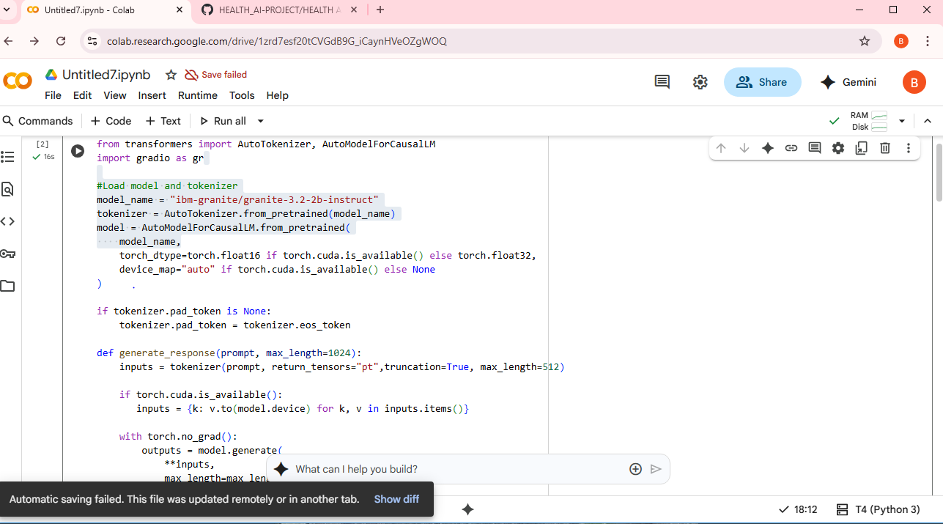

**12.Known Issues in the Medical AI Assistant Code**

I've mentioned these before, but here's a recap of the known issues in the code:

**1. Typos and incorrect names:**

- from_pertrained should be from_pretrained.

- AutomodelforcauusalLM should be AutoModelForCausalLM**.**

- gr.TabItem should be gr.Tab.

- lable should be label.

- mx_length should be max_length.

- genter should be gender.

**2. Potential logical issues:**

- input item should likely be inputs.items() in the generate_response function.

- inputs is used in model.generate(**inputs, ...), but input is defined earlier.